Create Node-RED Service

Steps followed:

* Navigated to the App creation page

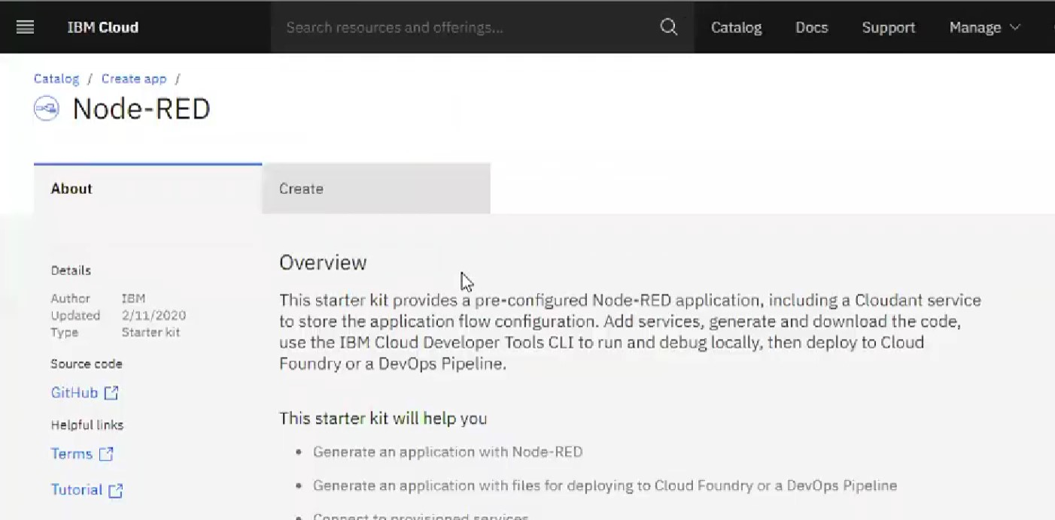

* Entered project details and clicked on create

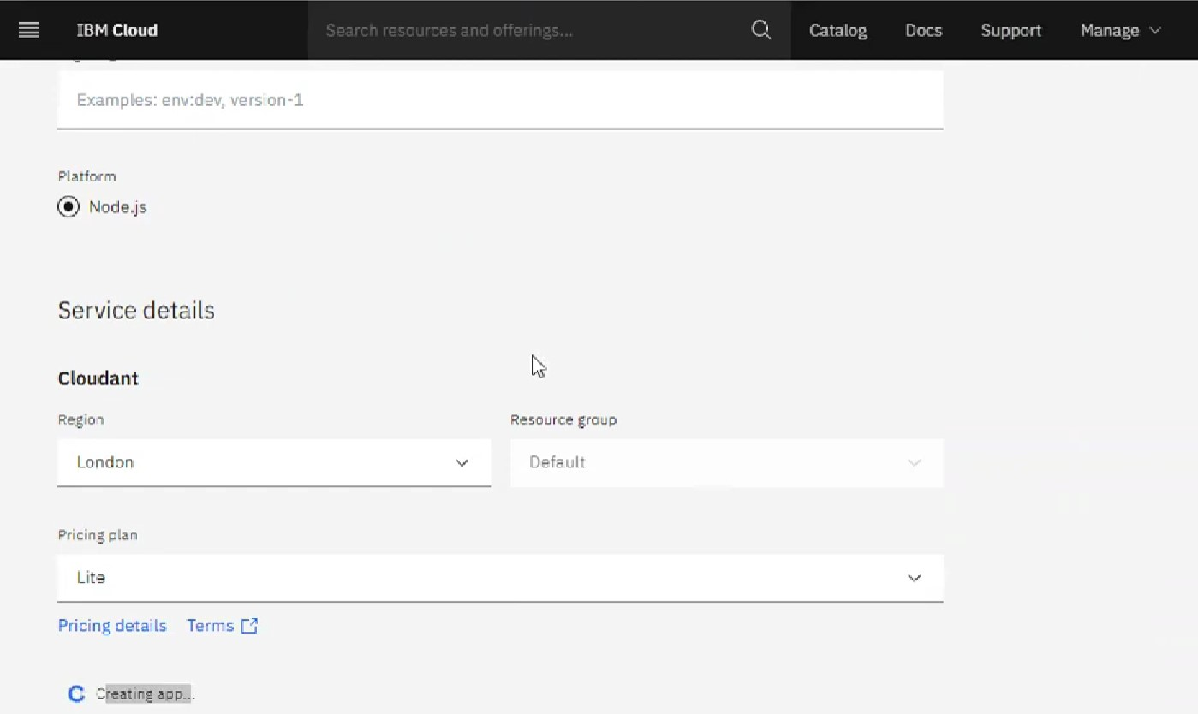

Clicking on the “Deploy your App” Button

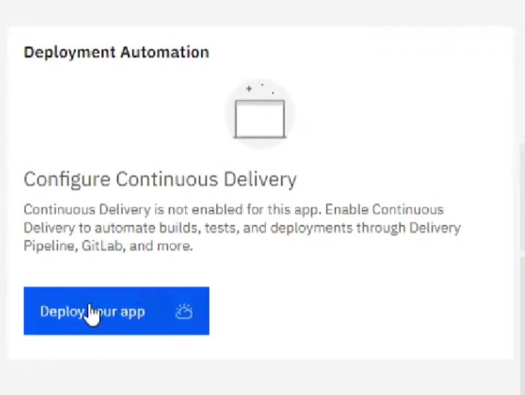

* Setting up the environment and deploying the app

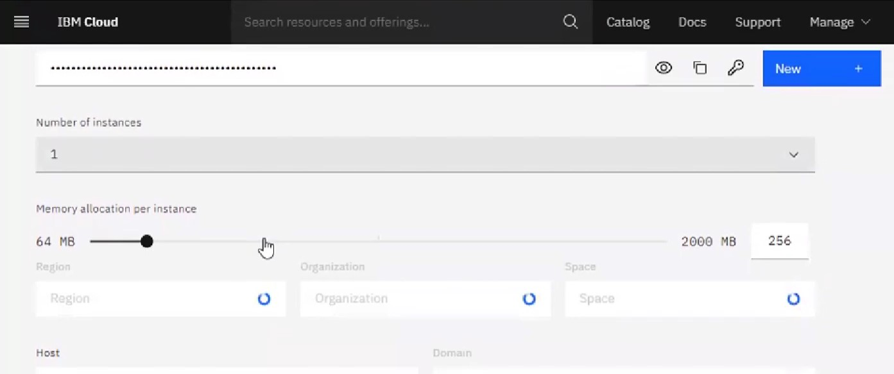

Successfully deployed the app

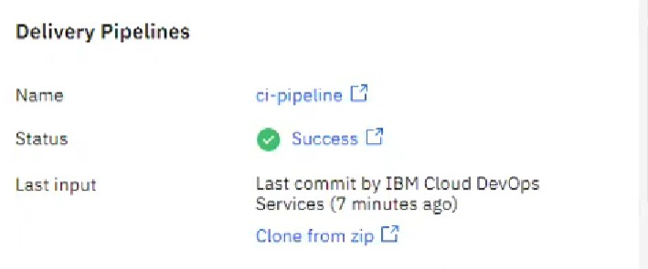

* Welcomed by the instance editor

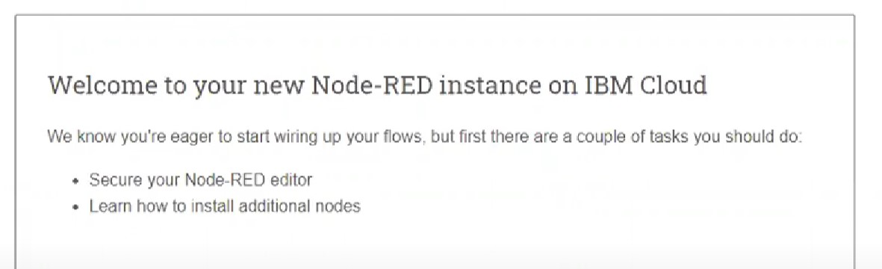

* Setting up credentials

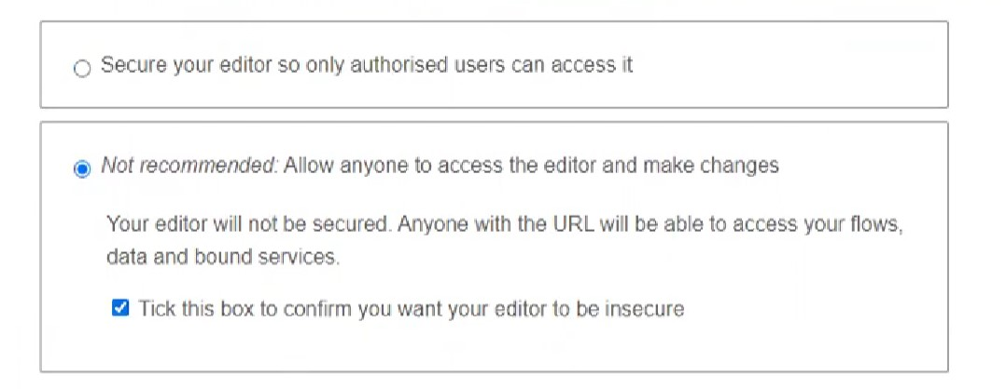

Dragged and dropped components into the editor

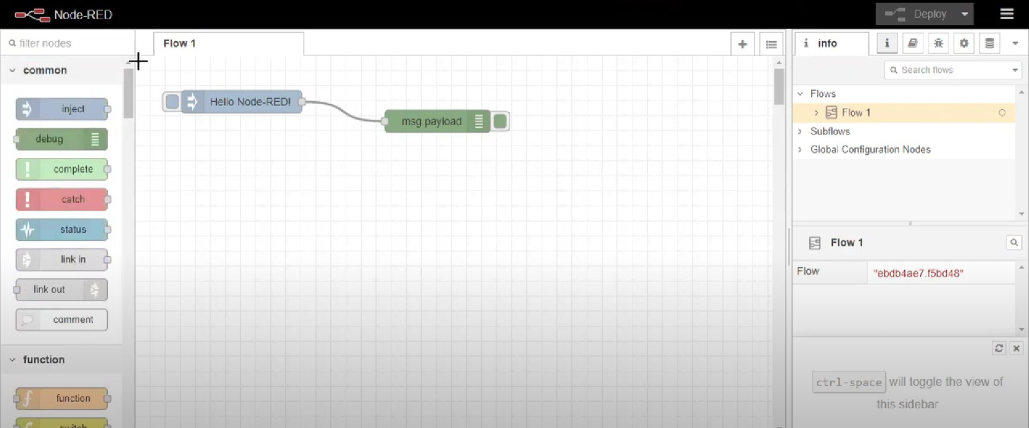

* Editing some values of the properties

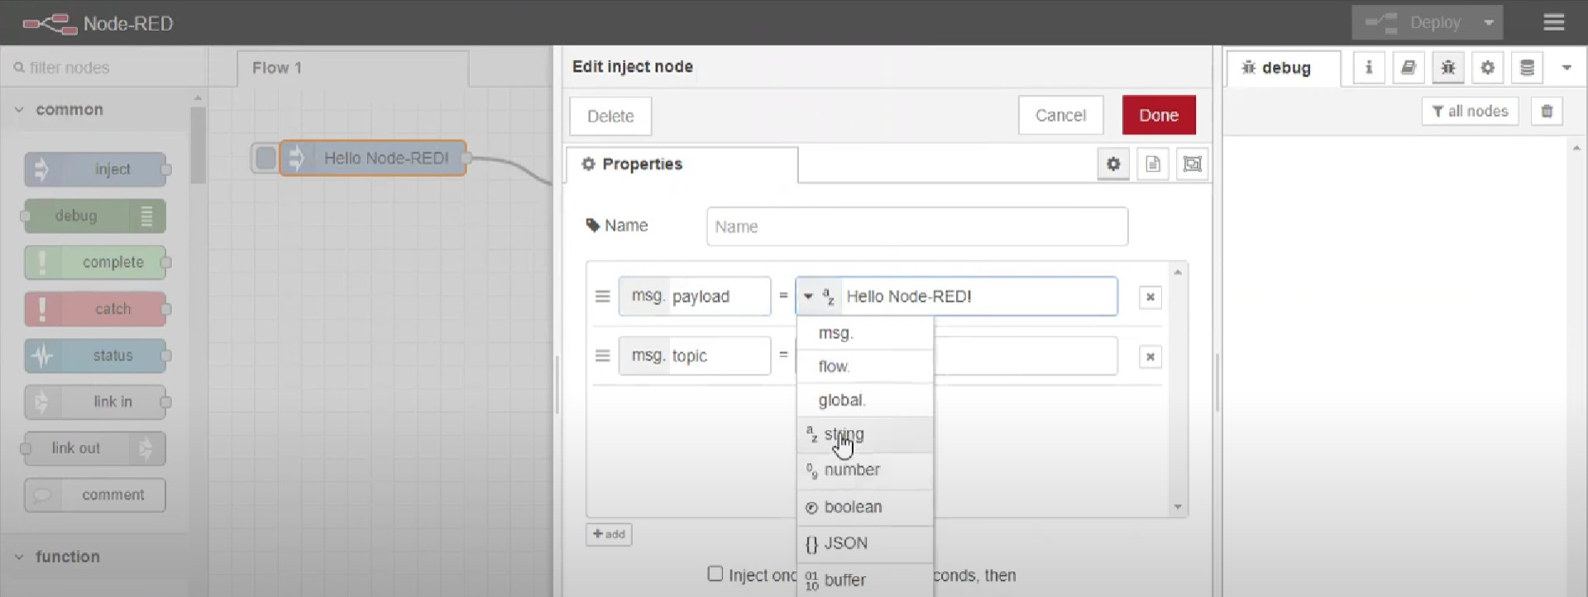

* Successfully deployed the app

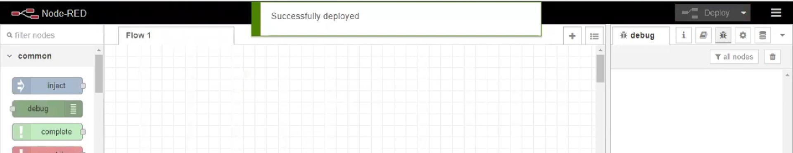

Result: Successfully created a NodeRED service on IBM Cloud